January 12, 2017

Specialized Press Contact
Janusz Berger
Communication Manager
High Performance Polymers
Phone +49 2365 49-9227
Janusz.berger@evonik.com
Evonik Resource Efficiency GmbH
Rellinghauser Straße 1-11
45128 Essen
Phone +49 201 177-01
Fax +49 201 177-3475
www.evonik.com

Supervisory Board
Dr. Ralph Sven Kaufmann, Chairman

Executive Board
Dr. Claus Rettig, Chairman
Dr. Johannes Ohmer,
Simone Hildmann,
Alexandra Schwarz

Registered Office: Essen
Register Court: Essen Local Court
Commercial Registry B 25783
VAT ID no. DE 815528487

Evonik to present VESTENAMER® for efficient tire production at Tire Technology Expo 2017

At Tire Technology Expo 2017 in Hanover, Germany, Evonik will present VESTENAMER®, a process additive with unique properties for efficient tire production.

The VESTENAMER® process additive simplifies the mixing and production of various tire compounds. It also improves dispersion of difficult polymer mixtures and reduces the viscosity of the compound while generally leaving the positive dynamic properties of the vulcanizate unaffected or increasing these even further in some cases.

Improved processability for rubber compounds
Advanced high-performance tires are required to have low rolling resistance and excellent wet traction combined with high abrasion resistance. This can be achieved only by using highly active fillers such as carbon black and especially precipitated silicas. Particularly when it comes to mixtures with high filler concentrations, multi-stage mixing processes is required in order to achieve a good dispersion. As a dispersion aid, VESTENAMER® can significantly shorten mixing cycles and at the same time optimize batch consistency in production. As a result the number of mixing steps in the process can be reduced and the process more efficiently designed.

High hardness, outstanding abrasion resistance, and very low compression set are the important requirements on compounds for rim strips. VESTENAMER® improves the processability of the rubber compound by reducing the viscosity at the mixing temperature and so preventing "bagging" at the rolling mill.

Thanks to its crystallinity and high recrystallization rate below the melting range, VESTENAMER® results in excellent dimensional stability in extrusion processes. By reducing internal friction, the addition of VESTENAMER® can significantly reduce the reversion of natural rubber. When mixing incompatible elastomers—due to differing polarities—Evonik's process additive can greatly improve compatibility.

A process additive with unique properties
VESTENAMER® is a semicrystalline additive also called trans-octenamer rubber (TOR). As a polymeric processing aid it acts as a plasticizer in rubber compounds during mixing and processing. However, during vulcanization of the rubber component it is crosslinked along with the rubber and as an elastomer is fully integrated into the polymer network. Thus, the excellent properties of the mixture remain stable in the final application.

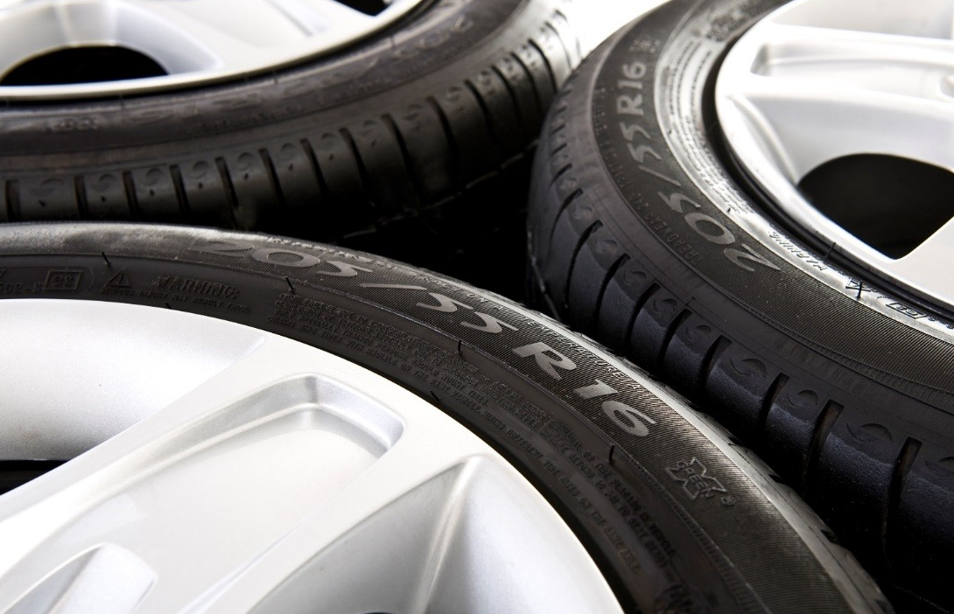
Photo caption: Evonik’s VESTENAMER® process additive improves the processability of rubber compounds.

Learn more about VESTENAMER® for efficient tire production at our booth, C816, at the Tire Technology Expo in Hanover between February 14 and 16.

Follow us on Twitter, LinkedIn, Facebook, and Google+

Further information is available at www.vestenamer.com

Company information
Evonik, the creative industrial group from Germany, is one of the world leaders in specialty chemicals, operating in the Nutrition & Care, Resource Efficiency and Performance Materials segments. The company benefits from its innovative prowess and integrated technology platforms. In 2015 more than 33,500 employees generated sales of around €13.5 billion and an operating profit (adjusted EBITDA) of about €2.47 billion.

About Resource Efficiency
The Resource Efficiency segment is led by Evonik Resource Efficiency GmbH and supplies high performance materials for environmentally friendly as well as energy-efficient systems to the automotive, paints & coatings, adhesives, construction, and many other industries. This segment employed about 8,600 employees, and generated sales of around €4.3 billion in 2015.

Disclaimer
In so far as forecasts or expectations are expressed in this press release or where our statements concern the future, these forecasts, expectations or statements may involve known or unknown risks and uncertainties. Actual results or developments may vary, depending on changes in the operating environment. Neither Evonik Industries AG nor its group companies assume an obligation to update the forecasts, expectations or statements contained in this release.

